1. 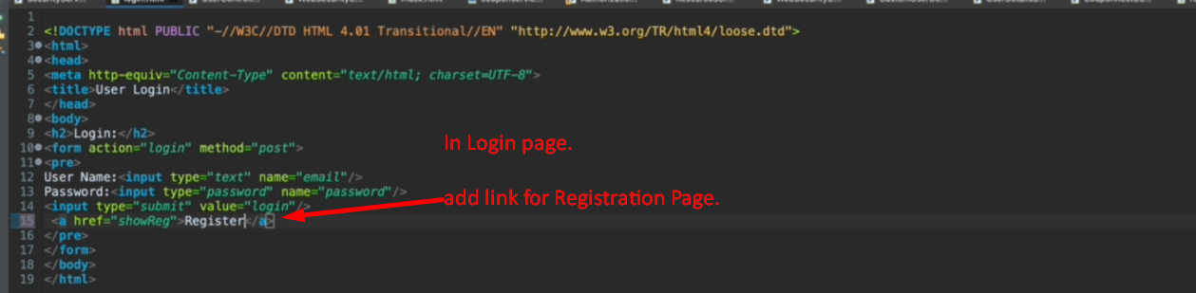
2. 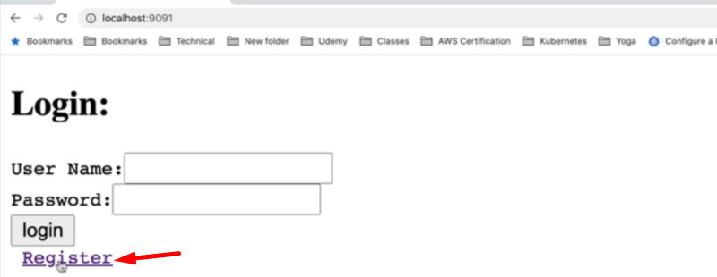
3. 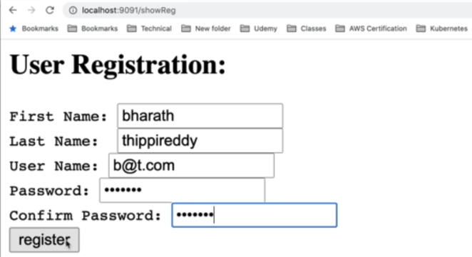
4. 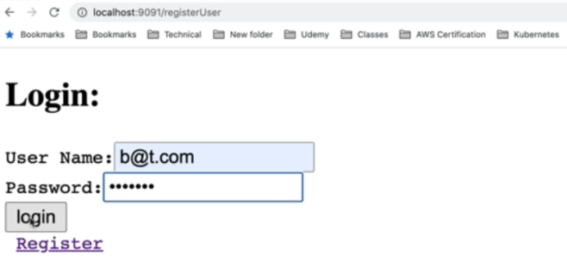
5. But in DB, the newly registered user doesn’t have any role.
6. So, the user can’t access any page after logging in.